Technology in Soccer

The Need for Goal Line Technology

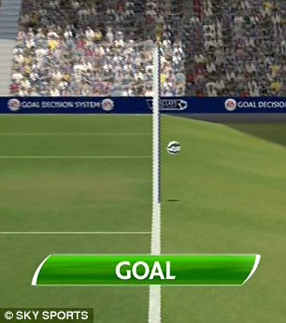 One thing that has been a huge issue in soccer are goals that shouldn’t be goals or shots that should have been goals. One time specifically comes to mind during a game I got to see live. During a Germany vs. England match of world cup in 2006, Frank Lampard had a goal that was not called as a goal. But video and picture evidence showed that the ref had made the wrong call.

After this moment, the IFAB started to look into Goal line technology systems. And in 2012 approved the use of goal line technology.

|  |  |  |  |  |  |  |
| --- | --- | --- | --- | --- | --- | --- |
|  | General | System | Ownership | Maintenance | Application | Replays |
| Before | No GLT | No GLT | No GLT | No GLT | No GLT | Accepted every ware |
| Now | Some GLT | Stadiums may use GLT that fits requirements | Competition | Supervised by competition | All competition matches | Accepted every ware |
| Future | All GLT | Stadiums must use GLT that fits requirements | Competition | Supervised by competition | All competition matches | Accepted every ware |

Design specifications

In order for the systems to work and be approved, the system had to detect that the ball had completely crossed the goal line. This must not only be accurate but also must be done within one second of the goal being scored. The system had to be accurate and alert the referee as soon as the decision had been made. Not only did a GLT system have to meet these requirements, but the system had to be tested and approved via the Final Installation Test(FIT) and the registered with FIFA itself.

How it Works

Goalref

There are two main types of GLT. The one used more commonly due to its cheap cost and high accuracy is called Goalref. Goalref uses a passive electronic circuit inside the ball and an electromagnetic field created in the goal mouth in order to tell if a ball has crossed the goal line. Once the chip and sensors in the ball all are in the electromagnetic field they immediately alert the ref through his watch. Telling him when a goal has been scored.

Hawk-eye

The other type of GLT is also used in tennis and cricket. It is called Hawk-Eye. Unlike Goalref, Hawk-Eye uses high speed cameras to follow the ball. The information is then sent through a system software that decides whether or not the ball crossed the goal line. The information is then radioed in to the referees watch.

Criticism

Similar to baseball, fans of the game are not interested in adding technology to remove human error. But because of the many times this has changed a game or even a tournament, many players and fans will agree that goal line technology is a wonderful addition to the beautiful game.

Resources

* <https://en.wikipedia.org/wiki/Goal-line_technology>
* <https://www.youtube.com/watch?v=o5QlBHF6ib8>
* <http://www.physics.org/article-questions.asp?id=125>
* <http://www.fifa.com/mm/document/fifaqualityprogramme/goal-linetechnology/02/01/77/01/gltweben.pdf>